Effect of Team and Year on Pit Stop Time in Formula 1
STAT 301-01: Analysis of Variance and Multivariate Analysis

Authors: Abduselam Mohammed
Owen Larson

Professor: Wei Wei

Term: Spring 2026

Institution: Metropolitan State University
St. Paul, MN

Introduction
This project examines Formula 1 pit stop data to study how pit stop time changes across teams and across different eras of the sport. Pit stop time is a useful performance measure because it reflects both technical efficiency and team execution, and it has also been affected by changes in rules, strategy, and technology over time. In this analysis, pit stop time is the response variable, while team, recorded as Car, and generation are the main explanatory variables. Generation separates the data into two eras, 1994–2005 and 2006–2010, to capture broad differences in Formula 1 conditions across time.
Before the analysis, the data were cleaned by converting pit stop time to numeric format, which introduced missing values where nonnumeric entries were coerced to NA. Those observations were removed before modeling. In addition to the ANOVA, a correlation scan was used to examine relationships among the numeric variables in the dataset. The most meaningful result from that scan was a moderate negative correlation between year and pit stop time, r = -0.345, suggesting that pit stops generally became faster over time. This supports the broader question of whether pit stop performance differs not only by team, but also by era, and whether team differences remain consistent across generations.

Research Questions
1. Do mean pit stop times differ across teams and across generations of Formula 1 cars?
2. Does the relationship between team and pit stop time change across generations, and how does pit stop time trend over the years?

Variables Used in the Analysis
Variable | Type | Meaning
Time | Quantitative | Pit stop duration for a single stop
Car | Categorical | Team or constructor name in the dataset
Generation | Categorical | Two eras: 1994–2005 and 2006–2010
Year | Quantitative | Season year, used for time trend and correlation scan

Hypotheses
For the main effect of team, H0: the mean pit stop time is the same across all teams.
Ha: at least one team has a different mean pit stop time.
For the main effect of generation, H0: the mean pit stop time is the same across generations. Ha: mean pit stop time differs between generations.
For the interaction between team and generation, H0: there is no interaction between team and generation on pit stop time. Ha: there is an interaction between team and generation on pit stop time.

Methods
A two-way ANOVA with an unbalanced design was used to analyze the data. This test is appropriate because the response variable is quantitative and the main explanatory variables are categorical. Because the number of observations differed across combinations of team and generation, Type II sums of squares were used for the main two-way ANOVA.
The statistical model used for the main analysis was Time = μ + Team + Generation + Team×Generation + ε. After a significant interaction was found, the data were separated by generation and one-way ANOVAs were used to examine team differences within each era. Tukey post-hoc comparisons were then used to identify which team pairs differed significantly.
A correlation analysis was also performed on the numeric variables in the dataset. This was not used as the main inferential method, but it helped describe the direction and strength of linear relationships, especially the overall relationship between year and pit stop time.

The Type II two-way ANOVA found a significant main effect of team, F(71, 9623) = 13.642, p < 0.001, and a significant main effect of generation, F(1, 9623) = 81.537, p < 0.001. The interaction between team and generation was also significant, F(3, 9623) = 4.070, p = 0.0067. This indicates that team differences in pit stop time are not constant across the two eras.
Because the interaction was significant, separate one-way ANOVAs were run within each generation. For Generation 1 (1994–2005), there was a significant effect of team, F(50, 6489) = 14.59, p < 0.001. For Generation 2 (2006–2010), there was also a significant effect of team, F(24, 3134) = 8.824, p < 0.001. These results show that teams differed significantly within both eras.
The correlation scan supported the time-based trend found in the ANOVA work. Year and pit stop time had a moderate negative correlation, r = -0.345, indicating that pit stop times generally became shorter over time. Stops and lap also had a noticeable positive correlation, r = 0.610, which is consistent with race structure, but those variables were not the primary focus of the project.

Summary of Main Statistical Results
Analysis | Effect | df | F | p-value
Two-way ANOVA | Team | 71, 9623 | 13.642 | < 0.001
Two-way ANOVA | Generation | 1, 9623 | 81.537 | < 0.001
Two-way ANOVA | Team × Generation | 3, 9623 | 4.070 | 0.0067
Gen1 one-way ANOVA | Team | 50, 6489 | 14.59 | < 0.001
Gen2 one-way ANOVA | Team | 24, 3134 | 8.824 | < 0.001
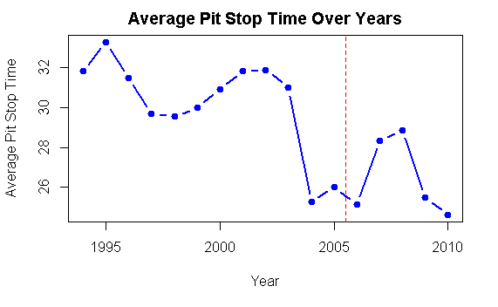
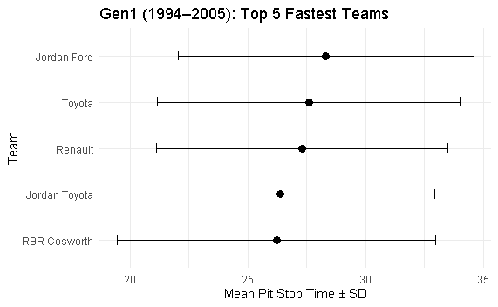

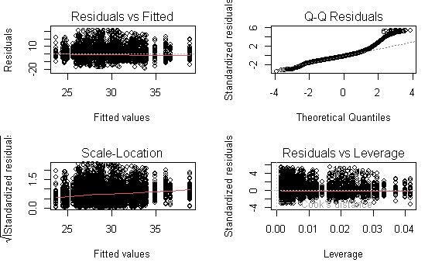

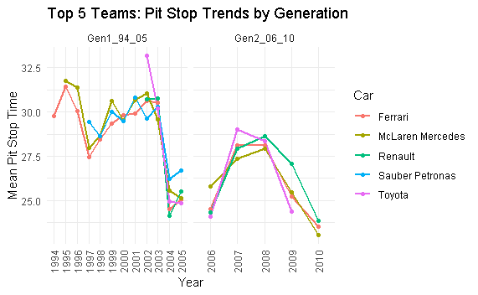

Discussion
The results show that pit stop performance is influenced by both team and generation, and that these effects are not independent. The significant interaction between team and generation indicates that team performance changes across eras, meaning that some teams adapt more effectively to regulatory and technological changes than others.
The observed decrease in pit stop times around 2004–2005 can be explained by changes in Formula 1 regulations. In 2005, tire change restrictions required drivers to complete races on a single set of tires, reducing the complexity of pit stops and resulting in shorter times. Additionally, this period reflects a peak in pit crew efficiency, with teams optimizing equipment and coordination. When tire changes were reintroduced in 2006, pit stop times increased again, which aligns with the trends observed in the data.
The Tukey analysis further reveals that certain teams exhibit significantly better performance than others, and that the magnitude of these differences varies between generations. This suggests that while overall improvements in pit stop efficiency occur over time, competitive advantages between teams are dynamic rather than fixed.

Conclusion
At a significance level of 0.05, the results indicate that pit stop times differ significantly across both teams and generations, and that there is a significant interaction between the two. This demonstrates that team performance is not consistent across eras and is influenced by changes in regulations and technology.
In context, these findings suggest that while Formula 1 as a whole has improved pit stop efficiency over time, individual teams respond differently to these changes. Some teams are able to adapt more effectively, leading to shifts in relative performance across generations. This highlights the importance of both innovation and adaptability in maintaining competitive advantage in Formula 1 racing.

Limitations
There are several limitations to this analysis. The dataset is unbalanced, with unequal representation of teams across years and generations. Additionally, team names may change over time due to sponsorship or organizational changes, which may affect continuity in the data. Other factors such as driver behavior, race conditions, and weather were not included in the analysis and may also influence pit stop time.
Despite these limitations, the results provide meaningful insight into how pit stop performance evolves across teams and regulatory eras.

